## DL Lab 3 Answer

John.jpg

Sample.jpg

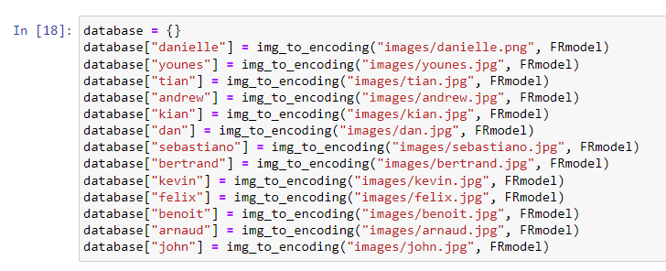

### Face verification

### Face Recognition

### Output[2]

